**Experiment 2**

**Aim**: Design a LED flasher

**Apparatus**: Arduino board,LED,Resistance-220 ohm,Wires

**Circuit Diagram**:

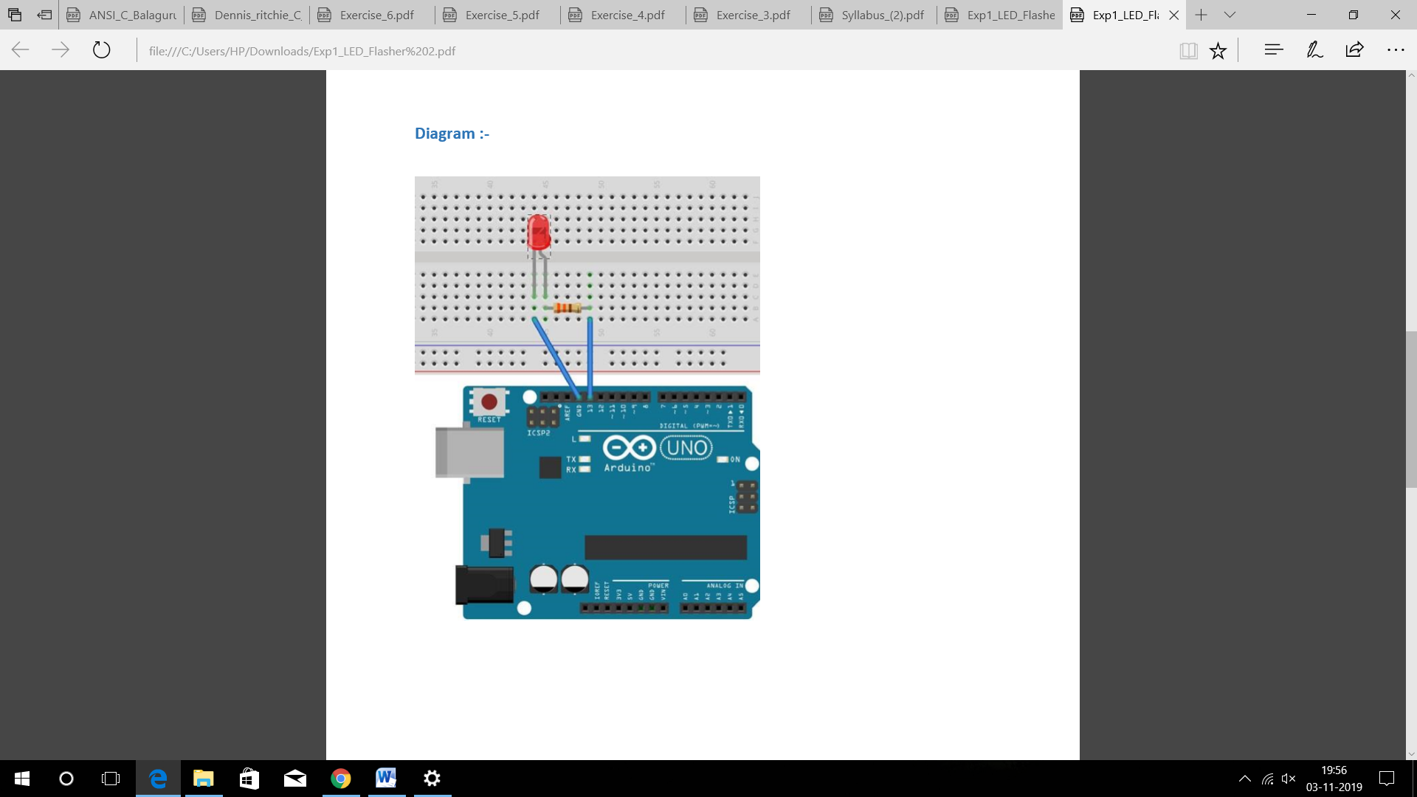

**Program**:

int led_flash=13;

void setup()

{

pinMode(led_flash,OUTPUT);

}

{

digitalWrite(led_flash,HIGH);

delay(1000);

digitalWrite(led_flash,LOW);

delay(1000);

}

**Precautions**:

* Do not reverse polarity.
* Do not plug it into unknown circuits.
* Do not short circuit.

**Result** :

Blinking of LED was verified after uploading the program.

**Learning Outcomes**:

* The working of Arduino Uno.
* How to code for LED flasher using arduino software.
* Applications of Arduino board.

**Sources of Error**:

* Improper connections on Arduino board.
* Errors in code written.